✅ 1. Data Collection
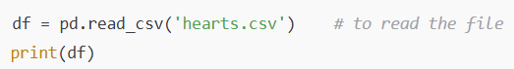
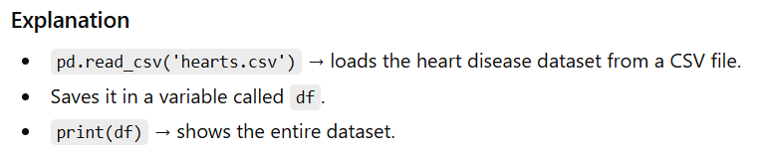
✅ 2. Data Preprocessing (Encoding Categorical Data)
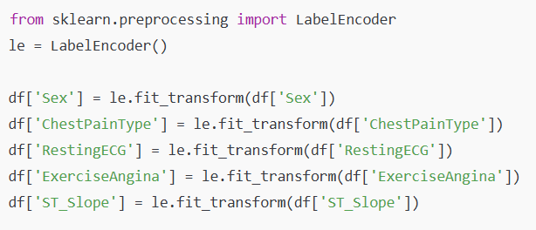
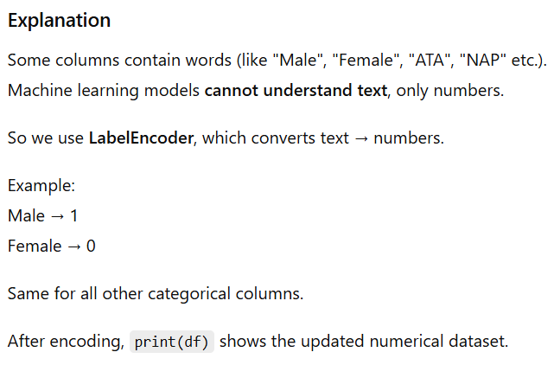
✅ 3. Splitting Input (X) and Output (Y)
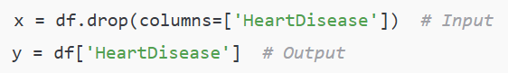
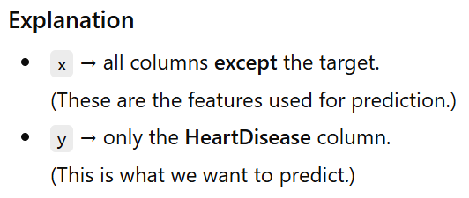
✅ 4. Train–Test Split
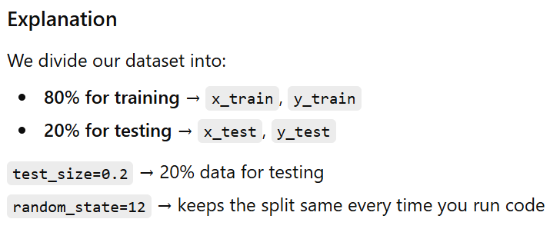
✅ 5. Model Training – Naive Bayes
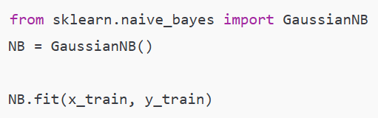

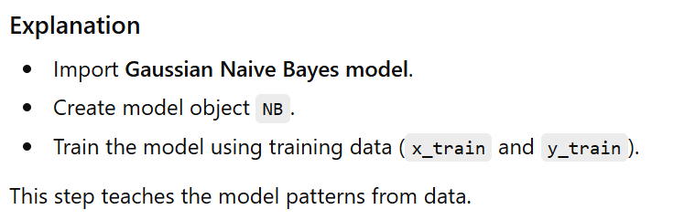✅ 6. Model Evaluation
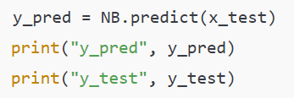
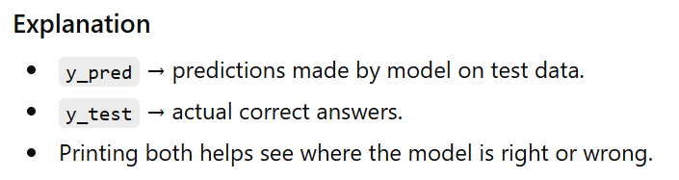
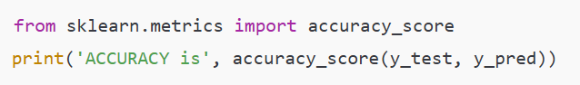
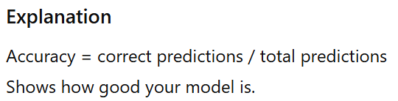

✅ 7. Model Prediction (For New Patient)
